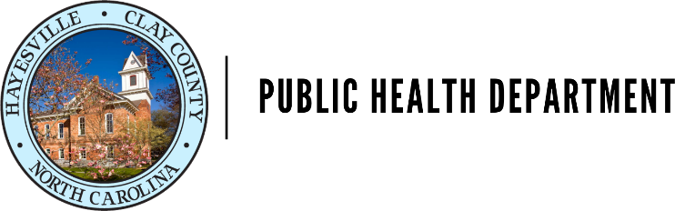

Environmental Health Division Receipt #: _______________
P.O. Box 55 Hayesville, NC 28904 Date: ___________________
(828) 389-8326

Name: _______________________________________Phone: ___________________Fax:________________

Mailing Address: ___________________________________________________________________________

Property Address: __________________________________________________________________________

Email:_____________________________________________________________________________________

Type of Water Supply:

Drill Well Bored Well Hand Dug Well Public Spring

Type of Treatment:

None Chlorinated Filtered

Water Sample For:

Bacteria…………………..$30 Pesticides………………….$100 Other ______________

Inorganic Chemistry….$100 Nitrates/Nitrites………..$75
(Metals Panel)
Volatile Organic Compound (VOC)…………………………………..$100

Health Department Water Sample Collection Request…….$50
*Note- Clay County Health Department will not collect samples from open wells with no covering, unprotected wells, unprotected springs, or known sources related to illness or outbreaks.

Date Sample Taken:_____________________________ Time:_____________AM/PM
*No sample should be sent from an open well, unprotected spring, or any other supply where there is visible evidence of possible contamination. Water from such sources is unsafe, regardless of laboratory findings.

*SAMPLES WILL ONLY BE ACCEPTED ON MONDAYS, TUESDAYS AND WEDNESDAY*. This form shall be submitted with water sample(s).

Receive findings by: Email Fax Mail Pick up

Bacteriological Test

The analysis determines the presence or absence of coliform bacteria and E. coli (Escherichia coli) bacteria. The analysis takes a minimum of 28 hours to perform. The analysis can run for only 48 hours maximum. The results will be sent per the request that was marked on the first page. You may call Environmental Health if you have any questions or concerns. (828) 389-8326.

Inorganic Chemistry (metal panel) Test

The analysis will check the following: Arsenic, Barium, Cadmium, Calcium, Chromium, Copper, Fluoride, Iron, Lead, Magnesium, Manganese, Mercury, Nickel, pH, Selenium, Silver, Sodium, Sulfate, Total Alkalinity, Total Hardness, and Zinc.

Directions for collecting water samples

Bacteriological:
- Do not rinse out the bottle. It contains a dichlorination agent, sodium thiosulfate.
- Take the sample from the well head or a house faucet tap. If the sample is required from a point other than the well head or house faucet tap, it should be designated on the form.
- The tap should be clean. If there is a screen or filter on the tap, remove it and clean the tap with alcohol or chlorine, rinse off before collecting the sample.
- Let the cold water run from the tap for 5 minutes to assure that the water is form the distribution system. let nothing but the water come into contact with the mouth of the bottle or inside the cap.
- Do not fill the bottle completely full. Leave approximately ½ air space at the top of the bottle. Fill the bottle to the 100ml line. Cap the bottle securely.
- If the sample is not returned to the Clay County Health Department with 1 HOUR of collection, it should be refrigerated until it is brought in. Samples over 30 hours old CAN NOT be tested.
- Do not mark or label cap.
- Return samples to front desk of Clay County Health Department.

Inorganic Chemistry (metal panel):
- Make sure the one-liter bottle has been inflated.
- Following steps 2-4 above.
- Fill and rinse the container several times
- Fill container to within 1” of the top, cap the bottle securely.
- Follow steps 7-8 above.

All other sample collections:
Directions for collection are provided on the back of the form with sample kit.

